Justice and Equity (Soul Matters Edition)
Covenant Group Session Plan
Greenville Unitarian Universalist Fellowship, Greenville, South Carolina
Based on material from Soul Matters-Small Group: The Gift of Justice and Equity - February 2024
Compiled and adapted by Jim Hennigan, February 2024

Welcome, Chalice Lighting: Here we are, together in this space. By our love and by our covenant, we make this a holy place. We light the chalice of Unitarian Universalism in honor of the light that lives in each of us, the light that shines among us, and the light we bring into the world.

Personal Check In: Briefly share something from your life since we last met and how you are feeling now.

Opening Words: “To understand the causes of poverty, we must look beyond the poor. Those of us living lives of privilege and plenty must examine ourselves… Most government aid goes to families that need it the least. If you add up the amount that the government is dedicating to tax breaks — mortgage interest deduction, wealth transfer tax breaks, tax breaks we get on our retirement accounts, our health insurance, our college savings accounts — you learn that we are doing so much more to subsidize affluence than to alleviate poverty… And this is the way we designed it.” - Matthew Desmond, Princeton sociologist in Poverty, by America (2023).
Questions to prompt and guide discussion:
- For many people, their first sense of injustice is one that is experienced personally (perhaps a sibling got a bigger slice of cake). How has your personal journey and understanding of justice/injustice evolved over time? Who has influenced your justice journey? What events disrupted your path?
- Acting for justice is most sustainable among people who understand their own self-interest is bound up in attaining justice. What sustaining self-interest is advanced by the justice causes that are most important or relevant to you? How are you connected with and personally aided by justice efforts?
- What role has your connection to Unitarian Universalism played in: your understanding of justice, your work for justice, and/or your personal sense of spirituality, healing, or hope as they relate to justice?
- “Justice” appears twice in the Seven Principles and Purposes of Unitarian Universalism. “Justice” and “Equity” are each separate “petals” within the proposed new Article II of the UUA By-laws (see next page for more). How does it feel to enter into a covenant to commit to act for justice and equity?
Readings – from the Common Bowl: The following pages with the readings are intended to be printed in duplex (or two-sided) mode and cut up as cards to be selected at random and read aloud by participants. You may assign readings if you prefer and/or decide how many readings to use during your time together to leave sufficient time for sharing and discussion. The fronts contain quotes, and the reverse side offers background.
Sharing - This is a time to speak without interruption and for deep listening. Deep listening means no interrupting, no fixing, no saving, no advising, and no setting each other straight. Please share one or more responses to the session questions.

(After each person has shared once without crosstalk, this can be a good time to take a brief break)
Open Discussion - This is a time to respond to something another person said about the topic or to relate additional thoughts that may have occurred as others shared their thoughts on this topic. Continue to practice deep listening.

Closing reading: "I am, somehow, less interested in the weight and convolutions of Einstein’s brain than in the near certainty that people of equal talent have lived and died in cotton fields and sweatshops."
– Stephen Jay Gould (1941-2002), Harvard paleontologist, in The Panda’s Thumb.
Announcements / Plans / Personal Check Out
Extinguish the Chalice We extinguish this flame but not the light of truth, the warmth of community, or the fire of commitment. These we carry in our hearts until we meet again.
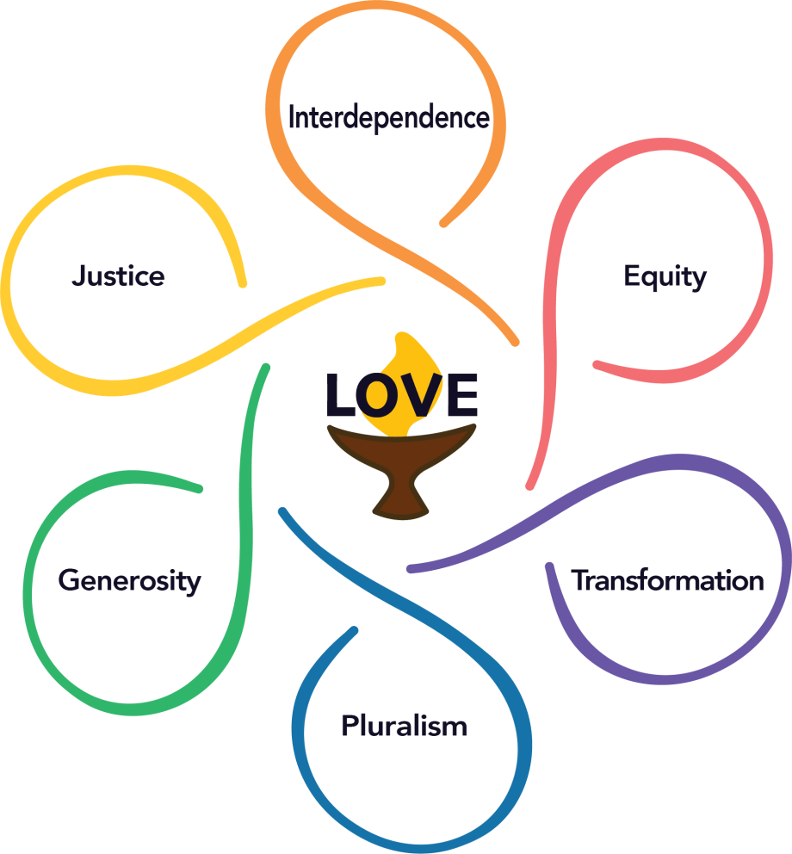

Justice - We work to be diverse multicultural Beloved Communities where all thrive.

We covenant to dismantle racism and all forms of systemic oppression. We support the use of inclusive democratic processes to make decisions within our congregations, our Association, and society at large.
Equity - We declare that every person has the right to flourish with inherent dignity and worthiness.
We covenant to use our time, wisdom, attention, and money to build and sustain fully accessible and inclusive communities.

I want there to be a place in the world where people can engage in one another’s differences in a way that is redemptive, full of hope and possibility. Not this ‘in order to love you, I must make you something else.’ That’s what domination is all about, that in order to be close to you, I must possess you, remake and recast you. – bell hooks | When those in power are caught abusing that power in ways that are morally indefensible and politically unpopular, they will always seek to turn an argument about oppression into a dispute about manners. – Adam Serwer
When I give food to the poor, they call me a saint. When I ask why the poor have no food, they call me a communist. - Hélder Câmara | I am no longer accepting the things I cannot change. I am changing the things I cannot accept. - Angela Davis
I sit on a man’s back, choking him and making him carry me, and yet assure myself and others that I am very sorry for him and wish to ease his lot by all possible means—except by getting off his back. – Leo Tolstoy | Poverty is rampant in wealthy nations because so many of us benefit from that situation. I read the novelist Tommy Orange’s first book, There, There and he has a line there that says, ‘kids are jumping out of the windows of burning buildings, falling to their deaths, and we think the problem is they’re jumping.’ When I read that I thought, ‘Man, that sounds like the poverty debate.’ We constantly focus on the poor. We should be focusing on the fire, who lit it, who’s warming their hands by it. Some lives are made small so that others may grow, and that’s just the plain truth of it. – Matthew Desmond
Unless we start to fight and defeat the enemies in our own country, poverty, and racism, and make our talk of equality and opportunity ring true, we are exposed in the eyes of the world as hypocrites when we talk about making people free. — Shirley Chisholm | The very serious function of racism … is distraction. It keeps you from doing your work. It keeps you explaining, over and over again, your reason for being. Somebody says you have no language and so you spend twenty years proving that you do. Somebody says your head isn’t shaped properly so you have scientists working on the fact that it is. Somebody says that you have no art, so you dredge that up. Somebody says that you have no kingdoms and so you dredge that up. None of that is necessary. — Toni Morrison
I learned that racism, like most systems of oppression, isn’t about bad people doing terrible things to people who are different from them but instead is a way of maintaining power for certain groups at the expense of others. — Alicia Garza | A democracy cannot thrive where power remains unchecked, and justice is reserved for a select few. Ignoring these cries and failing to respond to this movement is simply not an option—for peace cannot exist where justice is not served. — Rep. John Lewis

Journalist Adam Serwer, staff writer for The Atlantic, commenting on the outrage voiced in response to Rep. Alexandria Ocasio-Cortez’ choice of words when she noted that ICE detention centers operated as ‘concentration camps’ for children. The story was “A Crime By Any Name,” published in the July 2019 issue. | bell hooks (1952-2021), writing in “Reel to Real: Race, Sex and Class at the Movies.” hooks, a pen name for Gloria Jean Watkins, was an American author, theorist, educator, and social critic who was a Distinguished Professor in Residence at Berea College. She was best known for her writings on race, feminism, and class.
Angela Yvonne Davis is an American Marxist and feminist political activist, philosopher, academic, and author; she is a professor at the University of California, Santa Cruz. Davis was a longtime member of the Communist Party USA and a founding member of the Committees of Correspondence for Democracy and Socialism. | Hélder Câmara (1909-1999) was a Brazilian archbishop and advocate of liberation theology centered on the oppressed. A self-identified socialist (not a communist), he was the Archbishop of Olinda and Recife from 1964 to 1985, during the military dictatorship in Brazil, which the Catholic church was openly critical of.
Matthew Desmond is a professor of Sociology at Princeton University and the principal investigator of the Eviction Lab. He focuses on poverty and its causes and is the author of numerous books on the subject, including Poverty, by America (2023) and Evicted: Poverty and Profit in the American City (2016). | Leo Tolstoy (1828-1910) was a Russian novelist and, later in his life, he wrote shorter philosophical works which influenced the likes of Mahatma Gandhi. This quote is from one such book, What Then Must We Do?
Toni Morrison (1931-2019) was an American novelist. She was the first African American to win the Nobel Prize in Literature. This quote is taken from her 1975 keynote address, entitled “A Humanist View,” delivered at Portland State University Library’s Black Studies Dialogue, less than five years after her first novel was published. | In 1968, Shirley Chisholm (1924-2005) became the first black woman to be elected to the United States Congress. She represented New York's 12th congressional district, a district centered on Bedford–Stuyvesant, for seven terms from 1969 to 1983. In 1972, she became the first black candidate for a major-party nomination for President of the United States and the first woman to run for the Democratic Party's presidential nomination. Throughout her career, she was known for taking "a resolute stand against economic, social, and political injustices," as well as being a strong supporter of black civil rights and women's rights.
John Lewis (1940-2020) became an icon of the modern civil rights movement as a college student in Tennessee and later became a U.S. Representative from Georgia. This quote is a comment he made shortly before his death, in support of the George Floyd Justice in Policing Act. | Alicia Garza is an American civil rights activist and writer known for co-founding the Black Lives Matter movement. She is a recognized advocate for social and racial justice, with a particular focus on issues affecting marginalized communities, including Black women, LGBTQ+ individuals, and immigrants.

Press forward at all times, climbing forward toward that higher ground of the harmonious society that shapes the laws of man to the laws of God. — Adam Clayton Powell Jr | If you’re telling a non-Black person about something racist that happened to you, make sure you are not bitter. Don’t complain. Be forgiving. If possible, make it funny. Most of all, do not be angry. Black people are not supposed to be angry about racism. Otherwise, you get no sympathy. This applies only for White liberals, by the way. Don’t even bother telling a White conservative about anything racist that happened to you. Because the conservative will tell you that you are the real racist and your mouth will hang open in confusion.”— Chimamanda Ngozi Adichie
I imagine one of the reasons people cling to their hates so stubbornly is because they sense, once hate is gone, they will be forced to deal with pain. —James Baldwin | The more a man who belongs to the broad working masses is ‘non-political,’ the more susceptible he is to the ideology of political reaction. To be ‘non-political’ is not, as one might suppose, evidence of a passive psychic condition but of a highly active attitude, a defense against the awareness of social responsibility.” - Wilhelm Reich
If one really wishes to know how justice is administered in a country, one does not question the policemen, the lawyers, the judges, or the protected members of the middle class. One goes to the unprotected – those, precisely, who need the law’s protection most! – and listens to their testimony. – Eddie S. Glaude, Jr. | When we identify where our privilege intersects with somebody else's oppression, we'll find our opportunities to make real change. – Ijeomo Ojuo
No amount of legislation can grant you equality if a nation doesn’t value you. – Rev. Amiri B. Hooker | When a working stiff demands a pay raise, it causes inflation and threatens the nation’s prosperity; when a C.E.O. gets a raise ten thousand times as large, it rewards enterprise and assures all our futures. The two phenomena, obviously, are totally separate. Only a fool or a journalist could confuse them. --John Cassidy
There’s no more central theme in the Bible than the immorality of inequality. Jesus speaks more about the gap between rich and poor than he does about heaven and hell. -- Jim Wallis | Being physically imprisoned isn’t just being locked behind metal bars, it’s being trapped in abusive relationships, being bullied, raped, being dependent upon medication or drugs, and homelessness. All of these things have our bodies trapped in cycles that we can’t get out of. – Lailah Wideman

Chief Chimamanda Ngozi Adichie is a Nigerian-born and -educated writer whose works include novels, short stories and nonfiction, best known for the acclaimed novel, Half of a Yellow Sun (2007). This quote comes from her novel Amerikanah (2014) which won the National Book Critics Circle Award for Fiction. | Adam Clayton Powell Jr. (1908-1972) was an American Baptist pastor and politician who represented the Harlem neighborhood of New York City in the House of Representatives from 1945 until 1971. He authored bills that became the framework for the 1964 Civil Rights Act and was openly committed to grounding his politics on his faith values.
Wilhelm Reich (1897-1957) penned this in The Mass Psychology of Fascism (1933). Reich was an Austrian medical doctor, trained in psychiatry under Sigmund Freud. Most of his works were related to the sexual motivations of humans and, after immigrating to America, he later ventured into fields and misadventures that would discredit his earlier work. | James Baldwin (1924-1987) writing in The Fire Next Time, which was a national bestseller when it first appeared in 1963, The book, comprised of two letters or essays written on the occasion of the centennial of the Emancipation Proclamation, gave passionate voice to the emerging civil rights movement. It recalls Baldwin’s early life in Harlem and offers an eye-opening view into the consequences of racial injustice.
Ijeoma Oluo is an American writer, speaker and self-professed “internet yeller.” She is the author of the New York Times bestseller So You Want to Talk About Race (2018), as well as Mediocre: The Dangerous Legacy of White Male America (2020) and BE A REVOLUTION: How Everyday People are Fighting Oppression and Changing the World - and How You Can, Too (2024). | Eddie S. Glaude, Jr is an American academic, author, and current-affairs pundit. This quote comes from his bestselling book Begin Again: James Baldwin’s America and Its Urgent Lessons For Our Own.
John Cassidy is American journalist, author, and ex-patriate of the U.K., who frequently covers economics. This quote appeared in a comment entitled ’Gimme,” published in The New Yorker, April 21, 1997. | Rev. Amiri B. Hooker is a native of Bennettsville, SC and the minister at Wesley Chapel United Methodist Church in Lake City, SC. He is a Tri-Chair of the South Carolina Poor People’s Campaign and a preacher of Black liberation theology. This quote comes from his book My Banned Black History Sermons: Sermons About Jesus That Christian Nationalists Reject (2024).
Lailah Wideman is a Greenville (SC) Senior High School student and a youth member of the NAACP. This quote comes from her original essay Breaking the Chains of Physical Imprisonment, which she delivered at the 2023 NAACP National Afro-Academic, Cultural, Technological and Scientific Olympics (ACT-SO) in Boston, taking third place honors. | James E. Wallis Jr. is an American theologian, writer, teacher and political activist. He is best known as the founder and editor of Sojourners magazine (where this quote appeared in 1999) and as the founder of the Washington, DC-based Christian community of the same name.

The median Black household in America has around $24,000 in savings, investments, home equity, and other elements of wealth. The median White household: around $189,000, a disparity that has worsened in recent decades. … White Americans … are 28 times more likely to become millionaires. – Rand Corporation | An imbalance between rich and poor is the oldest and most fatal ailment of all republics. - Plutarch
Mere preaching is not enough. What are words, however sacred and powerful, in the presence of the grim facts of the daily struggle to survive? Any attempt to deal with this situation on a basis of values that disregard the struggle for survival appears to be in itself a compromise with life. It is only when people live in an environment in which they are not required to exert supreme effort into just keeping alive that they seem to be able to selects ends besides those of mere physical survival. ― Howard Thurman | I want people to see my color and my culture written all over me, because I am proud of the skin I'm in. It is an important part of my identity. What I don't want them to do is mistreat me because of it. – Luvvie Ajayi
There's an old saying in the black community that everybody else is protected and served but we are policed, we don't want to be policed. We want to be protected and served as any American citizen. – Benjamin Crump | Justice is what love looks like in public, just like tenderness is what love feels like in private. – Dr. Cornel West
Civil rights is unfinished business. Make it your business. – Secretary Marcia Fudge | Growing up in poverty, I learned some hard lessons about life. These lessons were taught to me not by my family but rather by system “helpers.” I learned that being poor offended people. I learned people had rage and anger toward me and others like me. I learned that people thought being poor equated to lacking intelligence, creativity, motivation and desire. I learned that people felt sorry for me. In the process, I also learned to be weary (and wary) of helpers. – Paul Gorski
A rat done bit my sister Nell. (with Whitey on the moon)  Her face and arms began to swell. (and Whitey's on the moon)  I can't pay no doctor bill. (but Whitey's on the moon)  Ten years from now I'll be payin' still. (while Whitey's on the moon)  Was all that money I made las' year (for Whitey on the moon?)  How come there ain't no money here? (Hm! Whitey's on the moon)  Y'know I jus' 'bout had my fill (of Whitey on the moon)  I think I'll sen' these doctor bills, Airmail special  (to Whitey on the moon) – Gil Scott-Heron | Liberation theology speaks to the ‘underside of history’ and offers perspectives on issues, such as poverty and oppression, that we might otherwise miss. This is especially important as we respond to social problems. To be in solidarity with those who are oppressed requires empathy and imagination. —Rev. Dr. Paul Rasor

Plutarch was a Greek Middle Platonist philosopher, historian, biographer, essayist, and priest at the Temple of Apollo in Delphi. He is known primarily for his Parallel Lives, a series of biographies of illustrious Greeks and Romans, and Moralia, a collection of essays and speeches. | https://www.rand.org/pubs/articles/2023/what-would-it-take-to-close-americas-black-white-wealth-gap.html (May 9, 2023). The Rand Corporation is a public policy think tank founded after World War II to produce research and reports relevant to American national defense. Long-regarded as a highly respected, conservative-leaning organization with well-vetted research; measured against the current political climate its work is now viewed as slightly left-leaning.
Luvvie Ajayi, also known as Luvvie Ajayi Jones, is a Nigerian American author, speaker, and digital strategist. Her book, I'm Judging You: The Do-Better Manual, was a New York Times best-seller. | Howard Washington Thurman (1899-1981) was an American author, philosopher, theologian, mystic, educator, and civil rights leader. As a prominent religious figure, he played a leading role in many social justice movements and organizations of the twentieth century. This quote is from Jesus and the Disinherited (1949), his classic treatise interpreting the Christian gospel as a manual of resistance.
Dr. Cornel West has been frequently quoted as saying this, or variations on it, in speeches and interviews. He is an academic, currently teaching at the Union Theological Seminary, having also taught at Harvard and Princeton universities. He is also an activist, public speaker, author (best known for Race Matters (1993)) and is an independent candidate for U.S. President in 2024. | Benjamin Lloyd Crump is an American attorney who specializes in civil rights and catastrophic personal injury cases such as wrongful death lawsuits. He has been the lead attorney in many prominent cases, including the estate of Henrietta Lacks, Tyre Nichols, the Buffalo shooting victims, the mother of Breonna Taylor, George Floyd’s family and more cases that are front page news.
Paul Gorski is the founder of the Equity Literacy Institute. He has helped educators in 48 states and a dozen countries strengthen their equity programs and practices in districts, schools, and classrooms. He has taught and published on justice movements including the sometimes negative and traumatizing impact of privileged allies. | Marcia Louise Fudge is an American attorney and politician serving as the 18th United States Secretary of Housing and Urban Development since 2021. A member of the Democratic Party, she served as the U.S. representative for Ohio's 11th congressional district from 2008 to 2021.
Paul Rasor is a Unitarian Universalist minister who has served congregations in Massachusetts. He is also the former director of the Center for the Study of Religious Freedom at Virginia Wesleyan College. This quote, from his book Faith Without Certainty: Liberal Theology in the 21st Century (2005) is part of the preface to the “Theology” chapter of the Widening the Circle of Concern report (2020) calling for systemic change within our denomination. | Gil Scott-Heron (1949 -2011) was an American jazz poet, musician, and author known for his work as a spoken-word performer in the ‘70s and ‘80s. This is an excerpt from “Whitey on the Moon,” written around the time of the Apollo 11 moon landing. This track was first available on his 1970 live album Small Talk at 125th and Lenox.

